Kenya School of Government collaborates with UN to strengthen infrastructure asset management in Kenya
The Kenya School of Government (KSG) is partnering with United Nations agencies, including UN DESA, UNCDF, and UNOPS, to launch an innovative training program aimed at improving the management and maintenance of public infrastructure in Kenya. This initiative addresses critical challenges posed by climate change, shrinking fiscal budgets, and urbanization, which strain the country’s public services. The goal is to bolster the resilience, sustainability, and accessibility of infrastructure assets that provide essential services, such as water and sanitation, waste management, and transportation.
In response to these pressing issues, a team of UN experts, led by Prof. Linda Newton, a global UN Advisor on Infrastructure Asset Management (IAM), conducted an intensive Training of Trainers workshop from June 23-27, 2024, for KSG faculty. This workshop aimed to enhance the faculty's capacity to deliver IAM programs to National and County Governments.
During the workshop's opening, Dr. Daniel Platz from UNDESA highlighted research by UNOPS and the University of Oxford, which indicates that infrastructure significantly impacts all 17 Sustainable Development Goals (SDGs), affecting up to 92% of their targets. He noted the severe economic consequences of under-maintained infrastructure, with potential annual losses amounting to 2% of the Gross Domestic Product (GDP).

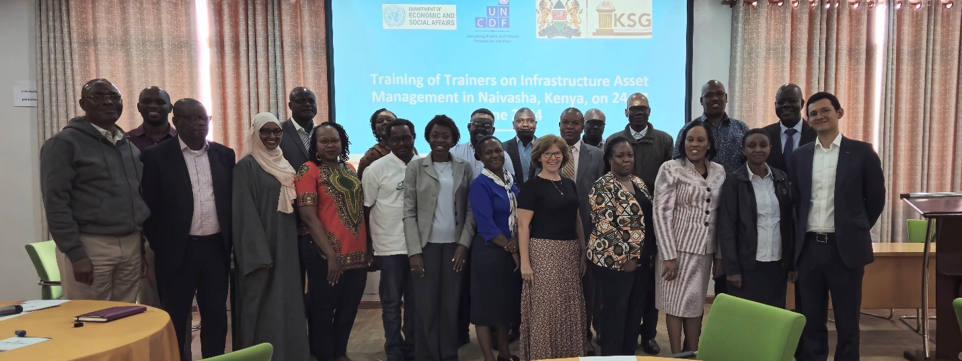 UN experts and staff from the School who attended a workshop on Infrastructure Asset Management
Mr. Humphrey Mokaya, Director of the Security Management Institute at KSG, underscored the importance of equipping public servants with the necessary competencies and tools to manage infrastructure investments effectively for sustainable impact. KSG plans to leverage the extensive UN training toolkits on IAM and adapt them to the Kenyan context.
Dr. Mkhululi Ncube of UNCDF emphasized the financial benefits of well-maintained infrastructure, stating, "Well-maintained infrastructure ensures reliable, equitable, and inclusive delivery of essential public services and significantly enhances fiscal space and promotes domestic resource mobilization. Between 70-85% of infrastructure costs typically occur after the construction phase. That is why IAM has become a central focus of UNCDF’s work on local government finance."
Mr. Luis Pineda of UN DESA reiterated the UN's commitment to ongoing collaboration with KSG in designing and integrating new asset management modules into existing programs and developing new training modules for county governments.
This partnership represents a significant step towards sustainable infrastructure management in Kenya, ensuring that public services remain resilient, accessible, and sustainable for all.

